Machine learning Interview question
What is tanh, ReLU and SIGMOID activation functions.
What is entropy?
hot encoding (OHE) on the categorical feature(s)
what is Skip gram model?
Word2vec algorithm?
Is it possible capture the correlation between continuous and categorical variable?
Is rotation necessary in PCA ?
Is K-Means an example of a deterministic algorithm?
Is it true that LogLoss evaluation metric can have negative values? NO
what is Confounding?

Requirement for Data Scientist
Skills required for Data Scientist:
- Fundamentals
- Statistics
- Programming
- Machine Learning and Advanced Machine Learning (Deep Learning)
- Data Visualization
- Big Data
- Data Ingestion
- Data Munging
- Tool Box
10. Data-Driven Problem Solving

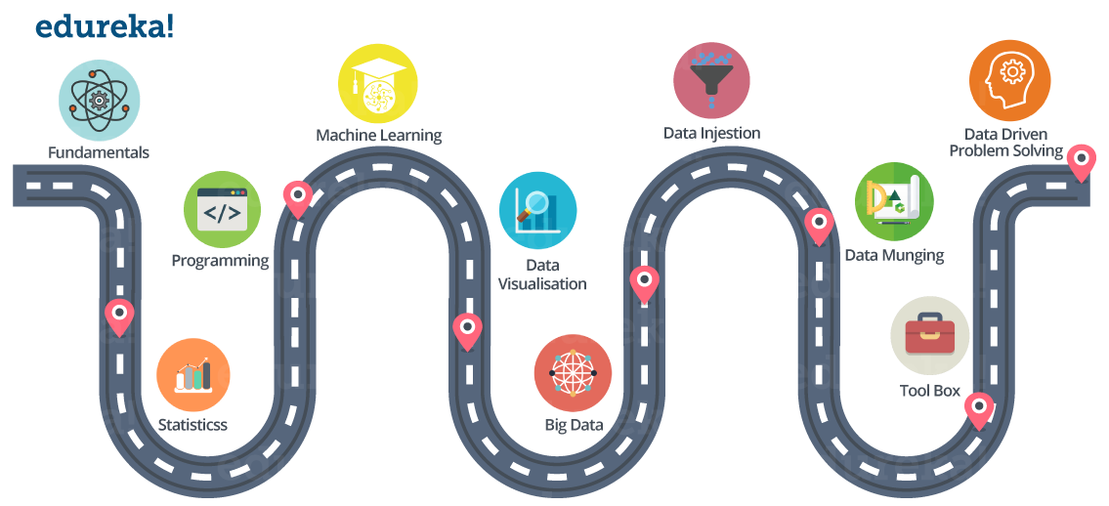

Fundamentals:
This includes:
- Matrices and Linear Algebra Functions
- Hash Functions and Binary Tree
- Relational Algebra, Database Basics
- ETL ( Extract Transform Load )
- Reporting VS BI (Business Intelligence) VS Analytics

Statistics:
This includes:
- Descriptive Statistics (Mean, Median, Range, Standard Deviation, Variance)
- Exploratory Data Analysis
- Percentiles and Outliers
- Probability Theory
- Bayes Theorem
- Random Variables
- Cumulative Distribution function (CDF)
- Skewness
- Other Statistics fundamentals
I would suggest you to pick a dataset from UCI repo. and start right now!

Programming:
Expertise in any one programming language, I would suggest ‘R’ or ‘Python.

Machine Learning and Advanced Machine Learning (Deep Learning):
Understand what is Machine learning and how it works.
Understand different types of Machine Learning techniques:
- Supervised Learning
- Unsupervised Learning
- Reinforcement Learning
Good knowledge on various Supervised and Unsupervised learning algorithms is required such as:
- Linear Regression
- Logistic Regression
- Decision Tree
- Random Forest
- K Nearest Neighbor
- Clustering (for example K-means)
Nowadays everyone is talking about Deep Learning, as it solved a lot of limitations of traditional Machine Learning approaches. Have to understand how Deep Learning works. I have listed down few Deep Learning concepts that you should be familiar with:
- Fundamentals of Neural Networks
- Any one library used for creating Deep Learning models, such as Tensorflow or Keras.
- Understand how Convolutional Neural Networks, Recurrent Neural Networks and RBM and Autoencoders work.

Data Visualization:
Data visualization is a very important part of Data life-cycle.
Good hands-on knowledge is required on various visualization tools. Even, you can use a programming language for that purpose.
Below are few visualization tools:
- Tableau
- Kibana
- Google Charts
- Datawrapper

Big Data:
Big Data is everywhere and there is almost an urgent need to collect and preserve whatever data is being generated, for the fear of missing out on something important.
There is a huge amount of data floating around. What we do with it is all that matters right now. This is why Big Data Analytics is in the frontiers of IT. Big Data Analytics has become crucial as it aids in improving business, decision makings and providing the biggest edge over the competitors. This applies for organizations as well as professionals in the Analytics domain.
As a Data Scientist it is very important to have knowledge about frameworks that can process Big Data. Two of the most famous ones are ‘Hadoop’ and ‘Spark’.

Data Ingestion:
The process of importing , transferring , loading and processing data for later use or storage in a database is called Data Ingestion. This involves loading data from a variety of sources.
Below are few Data Ingestion tools:
- Apache Flume
- Apache Sqoop

Data Munging:
If you have ever performed data analysis, you might have come across feature selection before you apply your Analytical model to the data.
So, in general, all the activity that you do on the raw data to make it “clean” enough to input to your analytical algorithm is data munging.
You can use ‘R’ and ‘Python’ packages for that.
It is one of the most important part of the data life-cycle.
As a Data Scientist you should be able to understand what all features are important in the dataset and what all features can be removed. You should also be able to identify your dependent variable or label.
Obviously, you have to remove inconsistency in the dataset.
All of these things are part of Data Munging (Data Wrangling).

Tool Box:
You might find this section pretty redundant, but I think it is very very important to have good knowledge on certain tools like:
- MS Excel
- Python or R
- Hadoop
- Spark
- Tableau

Data-Driven Problem Solving:
All the things we have discussed so far, includes tools and technologies that you can learn. But, Data-Driven problem solving approach is something that you need to develop. It will only come with experience.
A Data Scientist needs to know how to productively approach a problem.
This means identifying a situation’s
- salient features,
- figuring out how to frame a question that will yield the desired answer,
- deciding what approximations make sense, and
- consulting the right co-workers at the appropriate junctures of the analytic process.

Data Science vs Data Analytics vs Big Data
---------------------------------------------
Data science is like house that hold the tools and methods,where data analytics is specific room in that house.
Data Science is a field that comprises of everything that related to data cleansing, preparation, and analysis.
It is the combination of statistics, mathematics, programming, problem-solving, capturing data in ingenious ways, the ability to look at things differently, and the activity of cleansing, preparing and aligning the data.

It deals with semistructrued ,unstructured and structured data and helps in artificial intelligence and machine learning.
It is the umbrella of techniques used when trying to extract insights and information from data.

Data science delves into the world of the unknown by trying to find new patterns and insights. Instead of checking a hypothesis, like what is usually done with data analytics, data science tries to build connections and plan for the future.
Data science often moves an organization from inquiry to insights by providing new perspective into the data and how it is all connected that was previously not seen or known.

Data analytics is more focused than data science because instead of just looking for connections between data, data analysts have a specific goal in minding that they are sorting through data to look for ways to support. Data analytics is often automated to provide insights in certain areas.

The focus of Data Analytics lies in inference, which is the process of deriving conclusions that are solely based on what the researcher already knows.

Data Analytics the science of examining raw data with the purpose of drawing conclusions about that information.
Data Analytics involves applying an algorithmic or mechanical process to derive insights. For example, running through a number of data sets to look for meaningful correlations between each other.
It is used in a number of industries to allow the organizations and companies to make better decisions as well as verify and disprove existing theories or models.

Big Data is something that can be used to analyze insights which can lead to better decisions and strategic business moves.

Big Data refers to humongous volumes of data that cannot be processed effectively with the traditional approach. The processing of Big Data begins with the raw data that isn’t aggregated and is most often impossible to store in the memory of a single computer.

Both unstructured and structured, Big Data inundates a business on a day-to-day basis.

Big data is high-(volume,velocity,variety) information that demand cost-effective, innovative forms of information processing that enable enhanced insight, decision making, and process automation.

Difference roles:

Data Scientist -They take an big volume of messy data (unstructured and structured) and use their skills in math, statistics and programming to clean, massage and organize them.He is in charge of making predictions to help businesses take accurate decisions.Data scientists equipped with foundation of computer applications, modeling, statistics and math. He is responsible to solve business problems.

Data Analyst-They perform tasks like collecting, organizing data and obtaining statistical information out of them. he is responsible to present the data in the form of charts, graphs and tables and use the same to build relational databases for organizations. Analyst has depth knowledge of SQL.

Data Engineers-It is typically software engineers . data engineers are responsible for compiling and installing database systems, writing complex queries, scaling to multiple machines, and putting disaster recovery systems .They develop, construct, test and maintain architectures such as databases and large-scale data processing systems.

What is hypothesis testing?
Suppose, I've applied for a typing job and I've stated in my resume that my typing speed is 60 words per minute on an average. My recruiter may want to test my claim. If he finds my claim to be acceptable, he will hire me otherwise reject my candidature. So he asked me to type a sample letter and found that my speed is 54 words a minute. Now, he can decide on whether to hire me or not [assuming that I meet all other eligibility criteria]. This procedure depicts hypothesis testing in layman's terms.
In statistical terms: Hypotheses:
"my typing speed is 60 words per minute on an average" is a hypothesis to be tested, called null hypothesis.
Population & Sample: My average typing speed is population parameter and my sample typing speed is sample statistics.
Level of significance: The criteria of accepting /rejecting my claim is to be decided by the recruiter . For example, he may decide that an error of 5 words is ok to him so he would accept my claim between 55 to 65 words/minutes. In that case, my sample speed 54 words/minute will conclude to reject my claim. And the decision will be "I was making a false claim"
But if the recruiter extends his acceptance region to +/- 7 words [that is 53 to 67 words], he would be accepting my claim.

So, to conclude, Hypothesis testing is a process to test claims about the population on the basis of sample.

“A data lake is a storage repository that holds a vast amount of raw data in its native format, including structured, semi-structured, and unstructured data. The data structure and requirements are not defined until the data is needed.”
- Data. A data warehouse only stores data that has been modeled/structured, while a data lake is no respecter of data. It stores it all—structured, semi-structured, and unstructured. The data warehouse can only store the orange data, while the data lake can store all the orange and blue data.
- Processing. Before we can load data into a data warehouse, we first need to give it some shape and structure—i.e., we need to model it. That’s called schema-on-write. With a data lake, you just load in the raw data, as-is, and then when you’re ready to use the data, that’s when you give it shape and structure. That’s called schema-on-read. Two very different approaches.
- Storage.One of the primary features of big data technologies like Hadoop is that the cost of storing data is relatively low as compared to thedata warehouse.There are two key reasons for this: First, Hadoop is open source software, so the licensing and community support is free. And second, Hadoop is designed to be installed on low-cost commodity hardware.
- Agility. A data warehouse is a highly-structured repository, by definition. It’s not technically hard to change the structure, but it can be very time-consuming given all the business processes that are tied to it. A data lake, on the other hand, lacks the structure of a data warehouse—which gives developers and data scientists the ability to easily configure and reconfigure their models, queries, and apps on-the-fly.
- Security. Data warehouse technologies have been around for decades, while big data technologies (the underpinnings of a data lake) are relatively new. Thus, the ability to secure data in a data warehouse is much more mature than securing data in a data lake. It should be noted, however, that there’s a significant effort being placed on security right now in the big data industry. It’s not a question of if, but when.
- Users. A data lake, at this point in its maturity, is best suited for the data scientists.

What is the difference between classification and regression?
Regression is used to predict continuous values. Classification is used to predict which class a data point is part of (discrete value).
What is the difference between supervised and unsupervised learning?
Supervised learning is the Data mining task of inferring a function from labeled training data.The training data consist of a set of training examples.
In supervised learning, each example is a pair consisting of an input object (typically a vector) and a desired output value (also called the supervisory signal).
Differentiate between Data Science , Machine Learning and AI.
Data Science vs Machine Learning
Criteria | Data Science | Machine Learning | Artificial Intelligence
Defintion | Data Science is not exactly a subset of machine learning but it uses machine learning to analyse and make future predictions. | A subset of AI that focuses on narrow range of activities. | A wide term that focuses on applications ranging from Robotics to Text Analysis.
Role | It can take on a busines role. | It is a purely technical role. | It is a combination of both business and technical aspects.
Scope | Data Science is a broad term for diverse disciplines and is not merely about developing and training models. | Machine learning fits within the data science spectrum. | AI is a sub-field of computer science.
AI | Loosely integrated | Machine learning is a sub field of AI and is tightly integrated. | A sub- field of computer science consisting of various task like planning, moving around in the world, recognizing objects and sounds, speaking, translating, performing social or business transactions, creative work..

What’s the trade-off between bias and variance?
Bias is error due to erroneous or overly simplistic assumptions in the learning algorithm you’re using. This can lead to the modelunderfittingyour data, making it hard for it to have high predictive accuracy and for you to generalize your knowledge from the training set to the test set.
Variance is error due to too much complexity in the learning algorithm you’re using. This leads to the algorithm being highly sensitive to high degrees of variation in your training data, which can lead your model tooverfitthe data. You’ll be carrying too much noise from your training data for your model to be very useful for your test data.
Thebias-variance decompositionessentially decomposes the learning error from any algorithm by adding the bias, the variance and a bit of irreducible error due to noise in the underlying dataset. Essentially, if you make the model more complex and add more variables, you’ll lose bias but gain some variance — in order to get the optimally reduced amount of error, you’ll have totradeoffbias and variance. You don’t want either high bias or high variance in your model.
Q2- What is the difference between supervised and unsupervised machine learning?
Supervised learning requires training labeled data. For example, in order to do classification (a supervised learning task), will need to first label the data and use to train the model to classify data into your labeled groups. Unsupervised learning, in contrast, does not require labeling data explicitly.
Q3- How is KNN different from k-means clustering?
K-Nearest Neighbors is a supervised classification algorithm, while k-means clustering is anunsupervised clustering algorithm. While the mechanisms may seem similar at first, what this really means is that in order for K-Nearest Neighbors to work, you need labeled data you want to classify an unlabeled point into (thus the nearest neighbor part). K-means clustering requires only a set of unlabeled points and a threshold: the algorithm will take unlabeled points and gradually learn how to cluster them into groups by computing the mean of the distance between different points.
The critical difference here is that KNN needs labeled points and is thus supervised learning, while k-means doesn’t — and is thus unsupervised learning.
Q4- Explain how a ROC curve works.
The ROC curve is a graphical representation of the contrast between true positive rates and the false positive rate at various thresholds. It’s often used as a proxy for the trade-off between the sensitivity of the model (true positives) vs the fall-out or the probability it will trigger a false alarm (false positives).
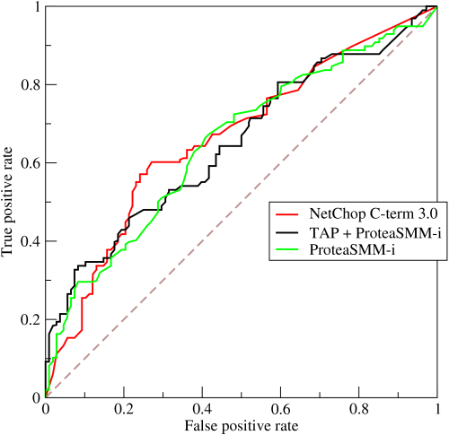
Q5- Define precision and recall.
Recall is also known as the true positive rate: the amount of positives your model claims compared to the actual number of positives there are throughout the data. Precision is also known as the positive predictive value, and it is a measure of the amount of accurate positives your model claims compared to the number of positives it actually claims. It can be easier to think of recall and precision in the context of a case where you’ve predictedthat there were 10 apples and 5 oranges in a case of 10 apples. You’d have perfect recall (there are actually 10 apples, and you predicted there would be 10) but 66.7% precision because out of the 15 events you predicted, only 10 (the apples) are correct.
Q6-What is Bayes’ Theorem? How is it useful in a machine learning context?
Bayes’ Theorem gives you the posterior probability of an event given what is known as prior knowledge.
Mathematically, it’s expressed as the true positive rate of a condition sample divided by the sumof the false positive rate of the population and the true positive rate of a condition. Say you had a 60% chance of actually having the flu after a flu test, but out of people who had the flu, the test will be false 50% of the time, and the overall population only has a 5% chance of having the flu. Would you actually have a 60% chance of having the flu after having a positive test?
Bayes’ Theorem says no. It says that you have a (.6 * 0.05) (True Positive Rate of a Condition Sample) / (.6*0.05)(True Positive Rate of a Condition Sample) + (.5*0.95) (False Positive Rate of a Population) = 0.0594 or5.94% chance of getting a flu.
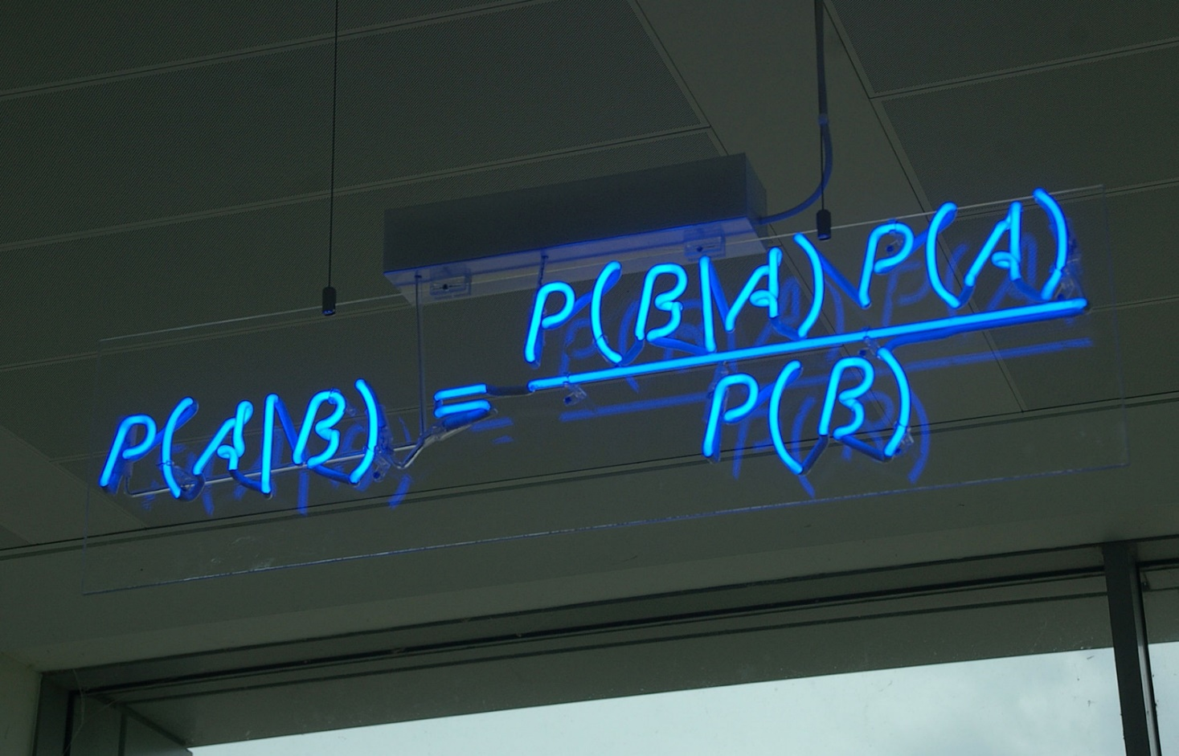
Bayes’ Theorem is the basis behind a branch of machine learning that most notably includes theNaive Bayes classifier. That’s something important to consider when you’re faced with machine learning interview questions.
Q7- Why is “Naive” Bayes naive?
Despite its practical applications, especially in text mining, Naive Bayes is considered “Naive” because it makes an assumption that is virtually impossible to see in real-life data: the conditional probability is calculated as the pure productof the individual probabilities of components. This implies the absolute independence of features — a condition probably never met in real life.
As a Quora commenter put it whimsically, a Naive Bayes classifier that figured out that you liked pickles and ice cream would probably naively recommend you a pickle ice cream.
Q8- Explain the difference between L1 and L2 regularization.
L2 regularization tends to spread error among all the terms, while L1 is more binary/sparse, with many variables either being assigned a 1 or 0 in weighting. L1 corresponds to setting a Laplacean prior on the terms, while L2 corresponds to a Gaussian prior.
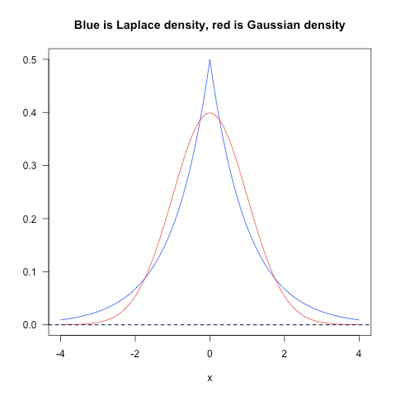
Q9- What’s your favorite algorithm, and can you explain it to me in less than a minute?
This type of question tests your understanding of how to communicate complex and technical nuances with poise and the ability to summarize quickly and efficiently. Make sure you have a choice and make sure you can explain different algorithms so simply and effectively that a five-year-old could grasp the basics!
Q10- What’s the difference between Type I and Type II error?
Don’t think that this is a trick question! Many machine learning interview questions will be an attempt to lob basic questions at you just to make sure you’re on top of your game and you’ve prepared all of your bases.
Type I error is a false positive, while Type II error is a false negative. Briefly stated, Type I error means claiming something has happened when it hasn’t, while Type II error means that you claim nothing is happening when in fact something is.
A clever way to think about this is to think of Type I error as telling a man he is pregnant, while Type II error means you tell a pregnant woman she isn’t carrying a baby.
Q11- What’s a Fourier transform?
A Fourier transform is a generic method to decompose generic functions into a superposition of symmetric functions. Or as this more intuitive tutorialputs it, given a smoothie, it’s how we find the recipe. The Fourier transform finds the set of cycle speeds, amplitudes and phases to match any time signal. A Fourier transform converts a signal from time to frequency domain — it’s a very common way to extract features from audio signals or other time series such as sensor data.
Q12- What’s the difference between probability and likelihood?
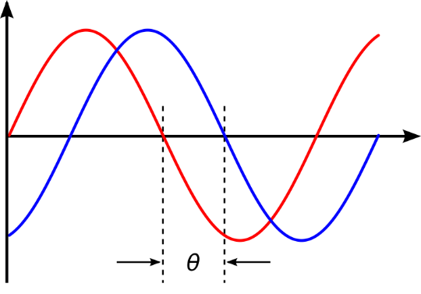
Q13-What is deep learning, and how does it contrast with other machine learning algorithms?
Deep learning is a subset of machine learning that is concerned with neural networks: how to use backpropagation and certain principles from neuroscience to more accurately model large sets of unlabelled or semi-structured data. In that sense, deep learning represents an unsupervised learning algorithm that learns representations of data through the use of neural nets.
Q14- What’s the difference between a generative and discriminative model?
A generative model will learn categories of data while a discriminative model will simply learn the distinction between different categories of data. Discriminative models will generally outperform generative models on classification tasks.
Q15- What cross-validation technique would you use on a time series dataset?
Instead of using standard k-folds cross-validation, you have to pay attention to the fact that a time series is not randomly distributed data — it is inherently ordered by chronological order. If a pattern emerges in later time periods for example, your model may still pick up on it even if that effect doesn’t hold in earlier years!You’ll want to do something like forward chaining where you’ll be able to model on past data then look at forward-facing data.
- fold 1 : training [1], test [2]
- fold 2 : training [1 2], test [3]
- fold 3 : training [1 2 3], test [4]
- fold 4 : training [1 2 3 4], test [5]
- fold 5 : training [1 2 3 4 5], test [6]
Q16- How is a decision tree pruned?
Pruning is what happens in decision trees when branches that have weak predictive power are removed in order to reduce the complexity of the model and increase the predictive accuracy of a decision tree model. Pruning can happen bottom-up and top-down, with approaches such as reduced error pruning and cost complexity pruning.
Reduced error pruning is perhaps the simplest version: replace each node. If it doesn’t decrease predictive accuracy, keep it pruned. While simple, this heuristic actually comes pretty close to an approach that would optimize for maximum accuracy.
Q17- Which is more important to you– model accuracy, or model performance?
This question tests your grasp of the nuances of machine learning model performance! Machine learning interview questions often look towards the details. There are models with higher accuracy that can perform worse in predictive power — how does that make sense?
Well, it has everything to do with how model accuracy is only a subset of model performance, and at that, a sometimes misleading one. For example, if you wanted to detect fraud in a massive dataset with a sample of millions, a more accurate model would most likely predict no fraud at all if only a vast minority of cases were fraud. However, this would be useless for a predictive model — a model designed to find fraud that asserted there was no fraud at all! Questions like this help you demonstrate that you understand model accuracyisn’t the be-all and end-all of model performance.
Q18- What’s the F1 score? How would you use it?
The F1 score is a measure of a model’s performance. It is a weighted average of the precision and recall of a model, with results tending to 1 being the best, and those tending to 0 being the worst. You would use it in classification tests where true negatives don’t matter much.

Q19- How would you handle an imbalanced dataset?
An imbalanced dataset is when you have, for example, a classification test and 90% of the data is in one class. That leads to problems: an accuracy of 90% can be skewed if you have no predictive power on the other category of data! Here are a few tactics to get over the hump:
1-Collect more data to even the imbalances in the dataset.
2-Resample the dataset to correct for imbalances.
3-Try a different algorithm altogether on your dataset.
What’s important here is that you have a keen sense for what damage an unbalanced dataset can cause, and how to balance that.
Q20- When should you use classification over regression?
Classification produces discrete values and dataset to strict categories, while regression gives you continuous results that allow you to better distinguish differences between individual points. You would use classification over regression if you wanted your results to reflect the belongingness of data points in your dataset to certain explicit categories (ex: If you wanted to know whether a name was male or female rather than just how correlated they were with male and female names.)
Q21- Name an example where ensemble techniques might be useful.
Ensemble techniques use a combination of learning algorithms to optimize better predictive performance. They typically reduce overfitting in models and make the model more robust (unlikely to be influenced by small changes in the training data).
You could list some examples of ensemble methods, from bagging to boosting to a “bucket of models” method and demonstrate how they could increase predictive power.

Q22-How do you ensure you’re not overfitting with a model?
This is a simple restatement of a fundamental problem in machine learning: the possibility of overfitting training data and carrying the noise of that data through to the test set, thereby providing inaccurate generalizations.
There are three main methods to avoid overfitting:
1-Keep the model simpler: reduce variance by taking into account fewer variables and parameters, thereby removing some of the noise in the training data.
2-Use cross-validation techniques such as k-folds cross-validation.
3-Use regularization techniques such as LASSO that penalize certain model parameters if they’re likely to cause overfitting.
Q23-What evaluation approaches would you work to gauge the effectiveness of a machine learning model?
You would first split the dataset into training and test sets, or perhaps use cross-validation techniques to further segment the dataset into composite sets of training and test sets within the data. You should then implement a choice selection of performance metrics: here is a fairly comprehensive list. You could use measures such as the F1 score, the accuracy, and the confusion matrix. What’s important here is to demonstrate that you understand the nuances of how a model is measured andhow to choose the right performance measures for the right situations.
Q24- How would you evaluate a logistic regression model?
A subsection of the question above. You have to demonstrate an understanding of what the typical goals of a logistic regression are (classification, prediction etc.) and bring up a few examples and use cases.
Q25- What’s the “kernel trick” and how is it useful?
The Kernel trick involves kernel functions that can enable in higher-dimension spaces without explicitly calculating the coordinates of points within that dimension: instead, kernel functions compute the inner products between the images of all pairs of data in a feature space. This allows them the very useful attribute of calculating the coordinates of higher dimensions while being computationally cheaper than the explicit calculation of said coordinates.Many algorithms can be expressed in terms of inner products. Using the kernel trick enables us effectively run algorithms in a high-dimensional space with lower-dimensional data. Programming
These machine learning interview questions test your knowledge of programming principles you need to implement machine learning principles in practice. Machine learning interview questions tend to be technical questions that test your logic and programming skills: this section focuses more on the latter.
Q26- How do you handle missing or corrupted data in a dataset?
You could find missing/corrupted data in a dataset and either drop those rows or columns, or decide to replace them with another value.
In Pandas, there are two very useful methods: isnull() and dropna() that will help you find columns of data with missing or corrupted data and drop those values. If you want to fill the invalid values with a placeholder value (for example, 0), you could use the fillna() method.
Q27- Do you have experience with Spark or big data tools for machine learning?
You’ll want to get familiar with the meaning of big data for different companies and the different tools they’ll want. Spark is the big data tool most in demand now, able to handle immense datasets with speed. Be honest if you don’t have experience with the tools demanded, but also take a look at job descriptions and see what tools pop up: you’ll want to invest in familiarizing yourself with them.
Q28- Pick an algorithm. Write the psuedo-code for a parallel implementation.
This kind of question demonstrates your ability to think in parallelism and how you could handle concurrency in programming implementations dealing with big data. Take a look at pseudocode frameworks such asPeril-Land visualization tools such asWeb Sequence Diagramsto help you demonstrate your ability to write code that reflects parallelism.
Q29- What are some differences between a linked list and an array?
An array is an ordered collection of objects. A linked list is a series of objects with pointers that direct how to process them sequentially. An array assumes that every element has the same size, unlike the linked list. A linked list can more easily grow organically: an array has to be pre-defined or re-defined for organic growth. Shuffling a linked list involves changing which points direct where — meanwhile, shuffling an array is more complex and takes more memory.
Q30- Describe a hash table.
A hash table is a data structure that produces an associative array. A key is mapped to certain values through the use of a hash function. They are often used for tasks such as database indexing.
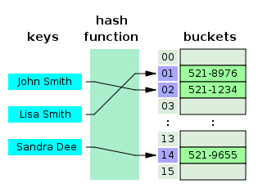
Q31- Which data visualization libraries do you use? What are your thoughts on the best data visualization tools?
What’s important here is to define your views on how to properly visualize data and your personal preferences when it comes to tools. Popular tools include R’s ggplot, Python’s seaborn and matplotlib, and tools such as Plot.ly and Tableau. Questions: These machine learning interview questions deal with how to implement your general machine learning knowledge to a specific company’s requirements. You’ll be asked to create case studies and extend your knowledge of the company and industry you’re applying for with your machine learning skills.
Q32- How would you implement a recommendation system for our company’s users?
A lot of machine learning interview questions of this type will involve implementation of machine learning models to a company’s problems. You’ll have to research the company and its industry in-depth, especially the revenue drivers the company has, and the types of users the company takes on in the context of the industry it’s in.
Q33- How can we use your machine learning skills to generate revenue?
This is a tricky question. The ideal answer would demonstrate knowledge of what drives the business and how your skills could relate. For example, if you were interviewing for music-streaming startup Spotify, you could remark that your skills at developing a better recommendation model would increase user retention, which would then increase revenue in the long run.
The startup metrics Slideshare linked above will help you understand exactly what performance indicators are important for startups and tech companies as they think about revenue and growth.
Q34- What do you think of our current data process? Learning Interest
Q35- What are the last machine learning papers you’ve read?
Keeping up with the latest scientific literature on machine learning is a must if you want to demonstrate interest in a machine learning position. This overview ofdeep learning in Natureby the scions of deep learning themselves (from Hinton to Bengio to LeCun) can be a good reference paper and an overview of what’s happening in deep learning — and the kind of paper you might want to cite.
Q36- Do you have research experience in machine learning?
Related to the last point, most organizations hiring for machine learning positions will look for your formal experience in the field. Research papers, co-authored or supervised by leaders in the field, can make the difference between you being hired and not. Make sure you have a summary of your research experience and papers ready — and an explanation for your background and lack of formal research experience if you don’t.
Q37- What are your favorite use cases of machine learning models?
Decision trees that categorize people into different tiers of intelligence based on IQ scores. Make sure that you have a few examples in mind and describe what resonated with you. It’s important that you demonstrate an interest in how machine learning is implemented.

Q38- How would you approach the “Netflix Prize” competition?
The Netflix Prize was a famed competition where Netflix offered $1,000,000 for a better collaborative filtering algorithm. The team that won called BellKor had a 10% improvement and used an ensemble of different methods to win. Some familiarity with the case and its solution will help demonstrate you’ve paid attention to machine learning for a while.
Q39- Where do you usually source datasets?
Machine learning interview questions like these try to get at the heart of your machine learning interest. Somebody who is truly passionate about machine learning will have gone off and done side projects on their own, and have a good idea of what great datasets are out there. If you’re missing any, check outQuandlfor economic and financial data, andKaggle’s Datasetscollection for another great list.
Q40- How do you think Google is training data for self-driving cars?
Machine learning interview questions like this one really test your knowledge of different machine learning methods, and your inventiveness if you don’t know the answer. Google is currently usingrecaptchato source labelled data on storefronts and traffic signs. They are also building on training data collected by Sebastian Thrun at GoogleX — some of which was obtained by his grad students driving buggies on desert dunes!
Q41- How would you simulate the approach AlphaGo took to beat Lee Sidol at Go?
AlphaGo beating Lee Sidol, the best human player at Go, in a best-of-five series was a truly seminal event in the history of machine learning and deep learning. The Nature paper above describes how this was accomplished with “Monte-Carlo tree search with deep neural networks that have been trained by supervised learning, from human expert games, and by reinforcement learning from games of self-play.”

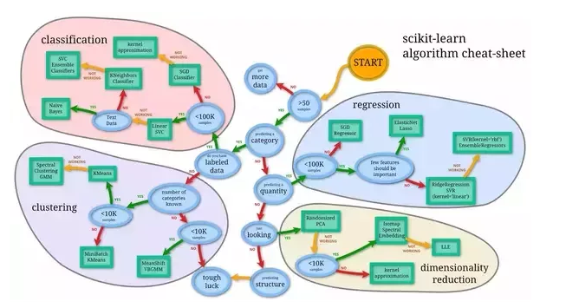
Q1. You are given a train data set having 1000 columns and 1 million rows. The data set is based on a classification problem. Your manager has asked you to reduce the dimension of this data so that model computation time can be reduced. Your machine has memory constraints. What would you do? (You are free to make practical assumptions.)
Answer:Processing a high dimensional data on a limited memory machine is a strenuous task, your interviewer would be fully aware of that. Following are the methods you can use to tackle such situation:
- Since we have lower RAM, we should close all other applications in our machine, including the web browser, so that most of the memory can be put to use.
- We can randomly sample the data set. This means, we can create a smaller data set, let’s say, having 1000 variables and 300000 rows and do the computations.
- To reduce dimensionality, we can separate the numerical and categorical variables and remove the correlated variables. For numerical variables, we’ll use correlation. For categorical variables, we’ll use chi-square test.
- Also, we can use PCA (principal component analysis)and pick the components which can explain the maximum variance in the data set.
- Using online learning algorithms like Vowpal Wabbit (available in Python) is a possible option.
- Building a linear model using Stochastic Gradient Descent is also helpful.
- We can also apply our business understanding to estimate which all predictors can impact the response variable. But, this is an intuitive approach, failing to identifyuseful predictors might result in significant loss of information.
Q2. Is rotation necessary in PCA(principal component analysis)? If yes, Why? What will happen if you don’t rotate the components?
Answer: Yes, rotation (orthogonal) is necessary because it maximizes the difference between variance captured by the component. This makes the components easier to interpret. Not to forget, that’s the motive of doing PCA where, we aim to select fewer components (than features) which can explain the maximum variance in the data set. By doing rotation, the relative location of the components doesn’t change, it only changes the actual coordinates of the points.
If we don’t rotate the components, the effect of PCA will diminish and we’ll have to select more number of components to explain variance in the data set.
Q3. You are given a data set. The data set has missing values which spread along 1 standard deviation from the median. What percentage of data would remain unaffected? Why?
Answer: This question has enough hints for you to start thinking!Since, the data is spread across median, let’s assume it’s a normal distribution. We know, in a normal distribution, ~68% of the data lies in 1 standard deviation from mean (or mode, median), which leaves ~32% of the data unaffected. Therefore, ~32% of the data would remain unaffected by missing values.
Q4. You are given a data set on cancer detection. You’ve build a classification model and achieved an accuracy of 96%. Why shouldn’t you be happy with your model performance? What can you do about it?
Answer: If you have worked on enough data sets, you should deduce that cancer detection results in imbalanced data. In an imbalanced data set, accuracy should not be used as a measure of performance because 96% (as given) might only be predicting majority class correctly, but our class of interest is minority class (4%) which is the people who actually got diagnosed with cancer. Hence, in order to evaluate model performance, we should use Sensitivity (True Positive Rate), Specificity (True Negative Rate), F measure to determine class wise performance of the classifier. If the minority class performance is found to to be poor, we can undertake the following steps:
- We can use undersampling, oversampling or SMOTE to make the data balanced.
- We can alter the prediction threshold value by doing probability caliberationand finding a optimal threshold using AUC-ROC curve.
- We can assign weight to classes such that the minority classes getslarger weight.
- We can also use anomaly detection.
Know more: Imbalanced Classification
Q5. Why is naive Bayes so ‘naive’ ?
Answer: naive Bayes is so‘naive’ because it assumes that all of the features in a data set are equally important and independent. As we know, these assumption are rarely true in real world scenario.

Q6. Explain prior probability, likelihood and marginal likelihood in context of naiveBayes algorithm?
Answer: Prior probability is nothing but, the proportion of dependent (binary) variable in the data set. It is the closest guess you can make about a class, without any further information. For example: In a data set, the dependent variableis binary (1 and 0). The proportion of 1 (spam) is 70% and 0 (not spam) is 30%. Hence, we can estimate that there are 70% chances that any new emailwould be classified as spam.
Likelihood is the probability of classifying a given observation as 1 in presence of some other variable. For example: The probability that theword ‘FREE’ is used in previousspam message is likelihood. Marginal likelihood is, the probability that the word ‘FREE’ is used in any message.

Q7. You are working on a time series data set. You manager has asked you to build a high accuracy model. You start with the decision tree algorithm, since you know it works fairly well on all kinds of data. Later, you tried a time series regression model and got higher accuracy than decision tree model. Can this happen? Why?
Answer: Time series data is known to posses linearity. On the other hand, a decision tree algorithm is known to work best to detect non – linear interactions. The reason why decision tree failed to provide robust predictions because it couldn’t map the linear relationship as good as a regression model did. Therefore, we learned that, a linear regression model can provide robust prediction given the data set satisfies its linearity assumptions.

Q8. You are assigned a new project which involves helping a food delivery company save more money. The problem is, company’s delivery team aren’t able to deliver food on time. As a result, their customers get unhappy. And, to keep them happy, they end up delivering food for free. Which machine learning algorithm can save them?
Answer: You might have started hopping through the list ofML algorithms in your mind. But, wait!Such questions are asked to test your machine learning fundamentals.
This is not a machine learning problem. This is a route optimization problem. A machine learning problem consist of three things:
- There exist a pattern.
- You cannot solve it mathematically (even by writing exponential equations).
- You have data on it.
Always look for these three factors to decide if machine learning is a tool to solve a particular problem.

Q9. You came to know thatyour model is suffering from lowbias and high variance. Which algorithm should you use to tackle it? Why?
Answer: Low bias occurs when the model’s predicted values are near to actual values. In other words, the model becomes flexible enough to mimic the training data distribution. While it soundslike great achievement, but not to forget, a flexible model has nogeneralization capabilities. It means, when this model is tested on an unseen data,it gives disappointing results.
In such situations, we can use bagging algorithm (like random forest) to tackle high variance problem. Bagging algorithms divides a data set into subsets made with repeated randomized sampling. Then, these samples are used to generate a set of models using a single learning algorithm. Later, the model predictions are combined using voting (classification) or averaging (regression).
Also, to combat high variance, we can:
- Use regularization technique, where higher model coefficients get penalized, hencelowering model complexity.
- Use top n features from variable importance chart. May be, with all the variable in the data set, the algorithm is having difficulty in findingthe meaningful signal.

Q10. You are given a data set. The data set contains many variables, some of which are highly correlated and you know about it. Your manager has asked you to run PCA. Would you remove correlated variables first? Why?
Answer: Chances are, you might be tempted to say No, but that would be incorrect. Discarding correlated variables have a substantial effect onPCA because, in presence of correlated variables, the variance explained by a particular component gets inflated.
For example: You have 3 variables in a data set, of which 2 are correlated.If you run PCA on this data set, the first principal component would exhibit twice the variance than it would exhibit with uncorrelated variables. Also, adding correlated variables lets PCA put more importanceon those variable, which is misleading.

Q11. After spending several hours, you are nowanxious to build a high accuracy model. As a result, you build 5 GBM models, thinking a boosting algorithm would do the magic. Unfortunately, neither of models could performbetter than benchmark score. Finally, you decided to combinethose models. Though, ensembled models are known to return high accuracy, but you are unfortunate. Where did you miss?
Answer: As we know, ensemble learners are based on the idea of combining weak learners to create strong learners. But, these learners provide superior result when the combined models are uncorrelated. Since, we have used 5 GBM models and got no accuracy improvement, suggests that the models are correlated. The problem with correlated models is, all the models provide same information.
For example: If model 1 has classified User1122 as 1, there are high chances model 2 and model 3 would have done the same, even if itsactual value is 0. Therefore, ensemble learners are built on the premise of combining weak uncorrelated models to obtain betterpredictions.

Q12. How is kNN different from kmeans clustering?
Answer:Don’t get mislead by ‘k’ in their names. You should know that the fundamental difference between both these algorithms is, kmeans is unsupervised in nature and kNN is supervised in nature. kmeans is a clustering algorithm. kNN is a classification (or regression) algorithm.
kmeans algorithm partitions a data set into clusters such that a cluster formed is homogeneous and the points in each cluster are close to each other. The algorithm tries to maintain enough separability between these clusters. Due to unsupervised nature, the clusters have no labels.
kNN algorithm tries to classify an unlabeled observation based on its k (can be any number ) surrounding neighbors. It is also known as lazy learner because it involves minimal training of model. Hence,it doesn’t use training data to make generalization on unseen data set.

Q13. How is True Positive Rate and Recall related? Write the equation.
Answer: True Positive Rate = Recall. Yes, they are equal having the formula (TP/TP + FN).
Know more: Evaluation Metrics

Q14. You have built a multiple regression model. Your model R² isn’t as good as you wanted. For improvement, your remove the intercept term, your model R² becomes 0.8 from 0.3. Is it possible? How?
Answer: Yes, it is possible. We need to understand the significance of intercept term in a regression model.Theintercept term showsmodel prediction without any independent variable i.e. mean prediction. The formula of R² = 1 – ∑(y – y´)²/∑(y – ymean)² where y´ is predicted value.
When intercept term is present, R² value evaluates your model wrt. to the mean model. In absence of intercept term (ymean), the model can make no such evaluation, with large denominator,∑(y - y´)²/∑(y)²equation’s value becomes smaller than actual, resulting in higher R².

Q15. After analyzing the model, your manager has informed that your regression model is suffering from multicollinearity. How would you check if he’s true? Without losing any information, can you still build a better model?
Answer: To check multicollinearity, we can create a correlation matrix toidentify & remove variables having correlation above 75% (deciding a threshold is subjective). In addition, we can use calculate VIF (variance inflation factor) to check the presence of multicollinearity.VIF value <=4 suggests no multicollinearity whereas a value of >= 10 implies serious multicollinearity. Also, we can use tolerance as an indicator of multicollinearity.
But, removing correlated variables might lead to loss of information. In order to retain those variables, we can use penalizedregressionmodels like ridge or lasso regression. Also, we can add some random noise in correlated variable so that the variables become different from each other. But, adding noise might affect the prediction accuracy, hence this approach should be carefully used.
Know more: Regression

Q16. When is Ridge regression favorable over Lasso regression?
Answer: You can quoteISLR’s authors Hastie, Tibshirani who asserted that, in presence of few variables with medium / large sized effect, use lasso regression. In presence of many variables with small / medium sized effect, use ridge regression.
Conceptually, we can say, lasso regression (L1) does both variable selection and parameter shrinkage, whereas Ridge regression only does parameter shrinkage and end up including all the coefficients in the model. In presence of correlated variables, ridge regression might be the preferred choice. Also, ridge regression works best in situations where the least square estimates have higher variance. Therefore, it depends on our model objective.
Know more: Ridge and Lasso Regression

Q17. Rise in global average temperature led to decrease in number of pirates around the world. Does that mean that decrease in number of pirates caused the climate change?
Answer: After reading this question, you should have understoodthat this is a classic case of “causation and correlation”. No, we can’t conclude thatdecrease in number of pirates caused the climate change because there might be other factors (lurking or confounding variables) influencing this phenomenon.
Therefore, there might be a correlation between global average temperature and number of pirates, but based on this information we can’t say that pirated died because of rise in global average temperature.
Know more: Causation and Correlation

Q18. While working on a data set, how do you select important variables? Explain your methods.
Answer: Following are the methods of variable selection you can use:
- Remove the correlated variables prior to selecting important variables
- Use linear regression and select variables based on p values
- Use Forward Selection, Backward Selection, Stepwise Selection
- Use Random Forest, Xgboost and plot variable importance chart
- Use Lasso Regression
- Measure information gain for the available set of features and select top n features accordingly.

Q19. What is the difference between covariance and correlation?
Answer:Correlation is the standardized form of covariance.
Covariances are difficult to compare. For example: if we calculate the covariances of salary ($) and age (years), we’ll get different covariances whichcan’t be compared because of having unequal scales. To combat such situation, we calculate correlation to get a value between -1 and 1, irrespective of their respective scale.

Q20. Is it possiblecapture the correlation between continuous and categorical variable? If yes, how?
Answer: Yes, we can use ANCOVA (analysis of covariance) technique to capture association between continuous and categorical variables.

Q21. Both being tree based algorithm, how is random forest different from Gradient boosting algorithm (GBM)?
Answer:The fundamental difference is, random forest uses bagging technique to make predictions. GBM uses boosting techniques to make predictions.
In bagging technique, a data set is divided into n samples using randomized sampling. Then, using a single learning algorithm a model is build on all samples. Later, the resultant predictions are combined using voting or averaging. Bagging is done is parallel. In boosting, after the first round of predictions, the algorithm weighs misclassified predictions higher, such that they can be corrected in the succeeding round. This sequential process of giving higher weights to misclassified predictions continue until a stopping criterion is reached.
Random forest improves model accuracy by reducing variance (mainly). The trees grown are uncorrelated to maximize the decrease in variance. On the other hand, GBM improves accuracy my reducing both bias and variance in a model.
Know more: Tree based modeling

Q22. Running a binary classification tree algorithm is theeasy part. Do you know how does a tree splitting takes place i.e. how does the tree decide which variable to split at the root node and succeeding nodes?
Answer:A classification trees makes decision based on Gini Index and Node Entropy. In simple words, the tree algorithm find the best possible feature which can divide the data setinto purest possible children nodes.
Gini index says, if we select two items from a population at random then they must be of same class and probability for this is 1 if population is pure. We can calculate Gini as following:
- Calculate Gini for sub-nodes, using formula sum of square of probability for success and failure (p^2+q^2).
- Calculate Gini for split using weighted Gini score of each node of that split
Entropy is the measure of impurity as given by (for binary class):
Here p and q is probability of success and failure respectively in that node. Entropy is zero when a node is homogeneous. It is maximum when a both the classes are present in a node at 50% – 50%. Lower entropy is desirable.

Q23. You’ve built a random forestmodel with 10000 trees. You got delighted after getting training error as 0.00. But, the validation error is 34.23. What is going on? Haven’t you trained your model perfectly?
Answer:The model has overfitted. Training error 0.00 means the classifier has mimiced the training data patterns to an extent, that they are not available in the unseendata. Hence, when this classifier wasrun on unseen sample, it couldn’t find those patterns and returned prediction with higher error. In random forest, it happens when we use larger number of trees than necessary. Hence, to avoid these situation, we should tune number of trees using cross validation.

Q24. You’ve got a data set to work havingp (no. of variable) > n (no. of observation). Why is OLS as bad option to work with? Which techniqueswould be best to use? Why?
Answer: In such high dimensional data sets, we can’t use classical regression techniques, since their assumptions tend to fail. When p > n, we canno longer calculate a unique least square coefficient estimate, the variances become infinite, so OLS cannot be used at all.
To combat this situation, we can use penalized regression methods like lasso, LARS, ridge which can shrink the coefficients to reduce variance. Precisely, ridge regression works best in situations where the least square estimates have higher variance.
Among other methods include subset regression, forward stepwise regression.

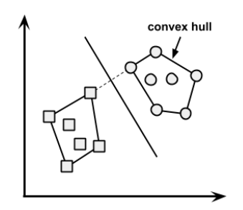Q25. What is convex hull ? (Hint: Think SVM)
Answer:In case of linearly separable data, convex hull represents the outer boundaries of the two group of data points. Once convex hull is created, we get maximum margin hyperplane (MMH) as a perpendicular bisector between two convex hulls. MMH is the line which attempts to create greatest separation between two groups.

Q26.We know that one hot encoding increasing the dimensionality of a data set. But, label encoding doesn’t. How ?
Answer: Don’t get baffled at this question. It’s a simple question asking the difference between the two.
Using one hot encoding, the dimensionality (a.k.a features) in a data set get increased because it creates a new variable for each level present in categorical variables. For example: let’s say we have a variable ‘color’. The variable has 3 levels namely Red, Blue and Green. One hot encoding ‘color’ variable will generate three new variables as Color.Red, Color.Blue and Color.Green containing 0 and 1 value.
In label encoding, the levels of a categorical variables gets encoded as 0 and 1, so no new variable is created. Label encoding is majorlyused for binary variables.

Q27.What cross validation technique would you use on time series data set? Is it k-fold or LOOCV?
Answer:Neither.
In time series problem, k fold can be troublesome because there might be some pattern in year 4 or 5 which is not in year 3. Resampling the data set will separatethese trends, and we might end up validation on past years, which is incorrect. Instead, we can use forward chaining strategy with 5 fold as shown below:
- fold 1 : training [1], test [2]
- fold 2 : training [1 2], test [3]
- fold 3 : training [1 2 3], test [4]
- fold 4 : training [1 2 3 4], test [5]
- fold 5 : training [1 2 3 4 5], test [6]
where 1,2,3,4,5,6 represents “year”.

Q28. You are given a data set consisting of variables having more than 30% missing values? Let’s say, out of 50 variables, 8 variables have missing values higher than 30%. How will you deal with them?
Answer: We can deal with them in the following ways:
- Assign a unique category to missing values, who knows the missing values might decipher some trend
- We can remove them blatantly.
- Or, we can sensibly check their distribution with the target variable, and if found any pattern we’ll keep those missing valuesand assignthem a new categorywhileremoving others.

29. ‘People who bought this, also bought…’ recommendations seen on amazon is a result of which algorithm?
Answer:The basic idea for this kind of recommendation engine comes from collaborative filtering.
Collaborative Filtering algorithm considers “User Behavior” for recommending items. They exploit behavior of other users and items in terms of transaction history, ratings, selection and purchase information. Other users behaviour and preferences over the items are used to recommend items to the new users. In this case, features of the items are not known.
Know more: Recommender System

Q30. What do you understand byType I vs Type II error ?
Answer: Type I error is committed when the null hypothesis is true and we reject it, also known as a ‘False Positive’. Type II error is committed when the null hypothesis is false and we accept it, also known as ‘False Negative’.
In the context of confusion matrix, we can say Type I error occurs when we classify a value as positive (1) when it is actually negative (0). Type II error occurs when we classify a value as negative (0) when it is actually positive(1).

Q31. You are working on a classification problem. For validation purposes, you’ve randomly sampled the training data set into train and validation. You are confident that your model will work incredibly well on unseen data since your validation accuracy is high. However, you get shocked after getting poor test accuracy. What went wrong?
Answer: In case of classification problem, we should always use stratified sampling instead of random sampling. A random sampling doesn’t takes into consideration the proportion of target classes. On the contrary, stratified sampling helps to maintain the distribution of target variable in the resultant distributed samples also.

Q32. You have been asked to evaluatea regression model based on R², adjustedR² and tolerance. What will be your criteria?
Answer: Tolerance (1 / VIF) is used as an indicator of multicollinearity. It is an indicator of percent of variance in a predictor which cannot be accounted by other predictors. Large values of tolerance is desirable.
We will consider adjusted R² as opposed to R² to evaluate model fit because R² increases irrespective of improvement in prediction accuracyas we add more variables. But, adjusted R² would only increase if an additional variable improves the accuracy of model, otherwise stays same. It is difficult to commit a general threshold value for adjusted R² because it variesbetween data sets. For example: a gene mutation data set might result in loweradjusted R² and still provide fairly good predictions, as compared to a stock market data whereloweradjusted R² implies that model is not good.

Q33. In k-means or kNN, we use euclidean distance to calculate the distance between nearest neighbors. Why not manhattan distance ?
Answer: We don’t use manhattan distance because itcalculates distance horizontally or vertically only. It has dimension restrictions. On the other hand, euclidean metriccan be used in any space to calculate distance. Since, the data points canbe present in any dimension, euclidean distance is a more viable option.
Example: Think of a chess board, the movement made by a bishop or a rook iscalculated by manhattan distance because of their respective vertical & horizontal movements.

Q34. Explain machine learning to me like a 5 year old.
Answer: It’s simple. It’s just like how babieslearn to walk. Every timethey fall down, they learn (unconsciously) & realize that their legs should be straight and not in a bend position. The next time they fall down, they feel pain. They cry. But, they learn ‘not to stand like that again’. In order to avoid that pain, theytry harder. To succeed, they even seek support from the door or wall or anything near them, which helps them stand firm.
This is how a machine works &develops intuitionfrom its environment.
Note: The interview is only trying to test if have the ability of explain complex concepts in simple terms.

Q35. I know that a linear regression model is generally evaluated using Adjusted R² or F value. How would you evaluate a logistic regression model?
Answer:We can use the following methods:
- Since logistic regression is used to predict probabilities, we can use AUC-ROC curve along with confusion matrix to determine its performance.
- Also, the analogous metric of adjusted R²in logistic regression is AIC. AIC is the measure of fit which penalizes model for the number of model coefficients. Therefore, we always prefer model with minimum AIC value.
- Null Deviance indicates the response predicted by a model with nothing but an intercept. Lower the value, better the model. Residual deviance indicates the response predicted by a model on adding independent variables. Lower the value, better the model.
Know more: Logistic Regression

Q36. Considering the long list of machine learning algorithm, given a data set, how do you decide which one to use?
Answer: You should say, the choice of machine learning algorithm solely depends of the type of data. If you are given a data set which is exhibits linearity, then linear regression would be the best algorithm to use. If you given to work on images, audios, then neural network would help you to build a robust model.
If the data comprises of non linear interactions, then a boosting or bagging algorithm should be the choice. If the business requirement is to build a model which can be deployed, then we’ll use regression or a decision tree model (easy to interpret and explain) instead of black box algorithms like SVM, GBM etc.
In short, there is no one master algorithm for all situations.We mustbe scrupulous enough to understand which algorithm to use.

Q37. Do you suggest that treatinga categorical variable as continuous variable would result in a better predictive model?
Answer:For better predictions, categorical variable can be considered as a continuous variable only when the variable is ordinal in nature.

Q38.When does regularization becomes necessary in Machine Learning?
Answer: Regularization becomes necessary when the model begins to ovefit / underfit. This techniqueintroduces a cost term for bringing in more features with the objective function. Hence, it tries to push the coefficients for many variables to zero and hence reduce cost term. This helps to reduce model complexity so that the model can become better at predicting (generalizing).

Q39. What do you understand by Bias Variance trade off?
Answer:The error emerging fromany model can be broken down into three components mathematically. Following are these component :
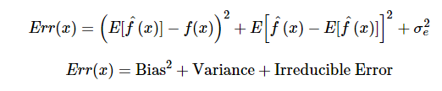
Bias error is useful to quantify how much on an average are the predicted values different from the actual value. A high bias error means we have a under-performing model which keeps on missing important trends.Variance on the other side quantifies how are the prediction made on same observation different from each other. A high variance model will over-fit on your training population and perform badly on any observation beyond training.

Q40. OLS is to linear regression. Maximum likelihood is to logistic regression. Explain the statement.
Answer: OLS and Maximum likelihood are the methods used by the respective regression methods to approximate the unknown parameter (coefficient) value. In simple words,
Ordinary least square(OLS) is a method used in linear regression which approximates the parameters resulting inminimum distance between actual and predicted values.Maximum Likelihood helpsin choosing the the values of parameters which maximizes the likelihood that the parameters are most likely to produce observed data.

